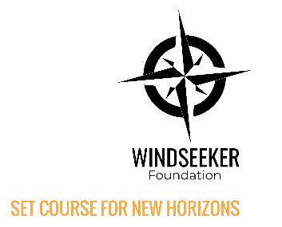
REFUNDING FORM / ERASMUS+ PROGRAM
THE NAME OF THE PROGRAM: Windseeker Foundation Mentor Training
FULL NAME OF THE PARTICIPANT: Click to enter text
PLACE: Amsterdam, the Netherlands
DATES: 27.03.2025. – 30.03.2025.

SENDING ORGANISATION OF THE PARTICIPANT
☐ Belgium: Stail Training Association Belgium  ☐ Denmark: Danish Sail Training Association  ☐ Estonia: Sail Training Association Estonia  ☐ France: Amis de Grande Voillers  ☐ Germany: University of Munster  ☐ Hungary: SOCTIRA | ☐ Ireland: Sail Training Ireland for Youth Development  ☐ Latvia: Sail Training Association Latvia  ☐ The Netherlands: Windseeker Foundation  ☐ Norway: Maritime Festival Langesund  ☐ Sweden: Sail Training Association Sweden  ☐ Other: Click to enter text

BANK INFORMATION FOR THE REFUND
FULL NAME OF ACCOUNT HOLDER: Click to enter text
IBAN CODE*: Click to enter text
BANK CURRENCY: Click to enter text
* This is an international code of your bank account, which we need to transfer the money. You can request this code at your bank.

RECEIPTS FOR OUTWARD JOURNEY (traveling to the training):
COUNTRY & CITY WHERE YOU TRAVELED FROM:
Click to enter text
DID YOU TRAVEL BY CAR? Yes ☐ No ☐
If not, fill out the table:
TYPE OF RECEIPT | AMOUNT | ORIGINAL CURRENCY
TOTAL

RECEIPTS FOR RETURN JOURNEY (traveling home):
COUNTRY & CITY WHERE YOU TRAVELED BACK TO:
Click to enter text
DID YOU TRAVEL BY CAR? Yes ☐ No ☐
If not, fill out the table:
TYPE OF RECEIPT | AMOUNT | ORIGINAL CURRENCY
TOTAL

OTHER COSTS AGREED TO BE REIMBURSED (optional)
Only the costs pre-approved by the Windseeker Foundation will be reimbursed!
TYPE OF RECEIPT | AMOUNT | ORIGINAL CURRENCY
TOTAL

GREEN TRAVEL (non-obligatory)
☐ I hereby confirm to have used only sustainable means of transport (train, bus or carpooling) to reach the project venue.
FULL AMOUNT FOR REIMBURSEMENT
Please add the costs from the above sections and provide the total in your bank account’s currency (if necessary, use the latest exchange rate): Click to enter text

Please add all of the receipts and combine them with this declaration into one PDF document. Upload the document on the Windseeker website, as directed.
DISCLAIMER:
Funded by the European Union. Views and opinions expressed are however those of the author(s) only and do not necessarily reflect those of the European Union or the European Education and Culture Executive Agency (EACEA). Neither the European Union nor EACEA can be held responsible for them.

